Testing RSU vitals

Test Case 3: The "Startup Millionaire" (Extreme Concentration)
This isolates the net worth and concentration math, simulating a mid-level employee whose company stock recently skyrocketed, dwarfing their other assets.
- Inputs:
  - Ticker/Shares: NVDA — 5,000 shares (Massive equity value)
  - Annual Gross Income: $150,000 (Mid-level income)
  - State: New York
  - Filing Status: Married Filing Jointly
  - Net Worth: $800,000
- Expected UI Outputs:
  - Concentration Gauge: Should be pinned to the extreme right (nearly 80%+ of net worth). The UI must scream "Danger" here.
  - Vesting Schedule: The Y-axis on the bar chart should scale cleanly to handle very high dollar amounts per vest without the labels overlapping or breaking the container layout.
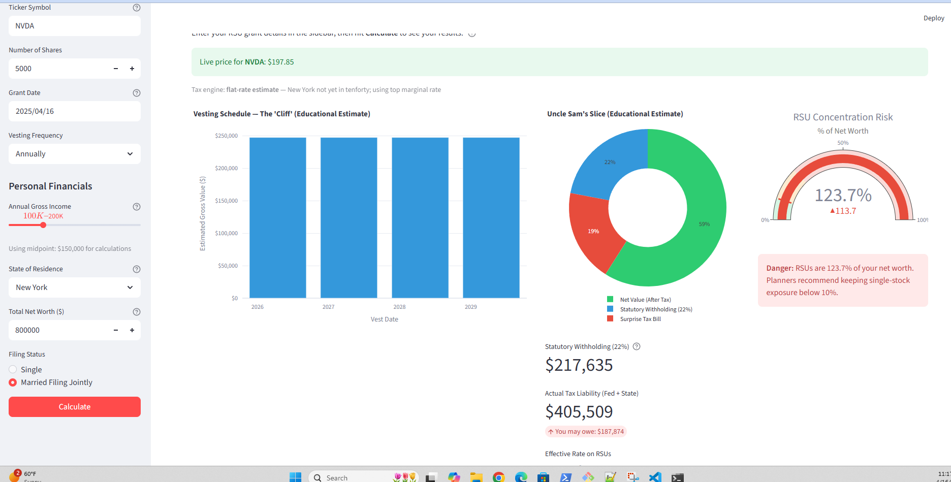

RESULT:

3. Test Case 3: The Startup Millionaire (The Edge Case)
The Y-axis scaled beautifully without breaking the container, which is a great UI win. However, we hit a fascinating edge case: the Concentration Gauge hit 123.7%.
Mathematically, this happens because the unvested value of the 5,000 NVDA shares (~$989k) is larger than their current inputted Net Worth ($800k).
- The Fix: To avoid user confusion, you might want to slightly tweak the tooltip or label to say "Unvested RSUs represent [X]% of your current net worth" or add a toggle that asks if the $800k net worth already includes vested company stock. Either way, the UI handled the overflow perfectly by pinning the gauge in the red zone.

